WAYS FOR US TO ENGAGE:

In Church
  - Get to know your neighbour and arrange to meet for a chat.
  - Use the “Journeying Together” sheets available at the Comments Boxes in church porches. These are also available on the website.
  - Post your sheet with comments, ideas, thoughts etc. in a Comments Box (response post cards available for those who prefer).

In the Hall and Social Centre
  - Discuss with the group around your coffee table.
  - Use the “Journeying Together” sheets or response post cards and put these in the Comments box available.
  - Use Post-It notes to record your reflections, comments, ideas, thoughts etc. and attach to the flipchart.

At Home and in the Workplace
  - Discuss with family around the dining table, or with friends and colleagues where possible (whether practising Catholics or not).
  - Use the ‘Journeying Together’ sheets available from church.
  - Post your “Journeying Together’ sheets or response post cards with reflections etc. in a Comments Box in the church porch or the hall.
OR

  - Written reflections to be received by the Bishop’s Office, Cathedral House, 13 Belmont, Shrewsbury, SY1 1TE by 1st March 2022 either by post or email from individuals (or groups). Synod@dioceseofshrewsbury.org

Pray, Pray, Pray!
  - The Prayer of the Synod (see Newsletter)
  - Personal prayers
  - Remember – “It is ... first and foremost, a spiritual process ...”

WEBSITE RESOURCES

- Synod questions
- Week by week Addresses to Parish
- “Ways to Engage” sheet and “Journeying Together” sheet.

All available at http://sscolumbaandtheresa.co.uk/Synod

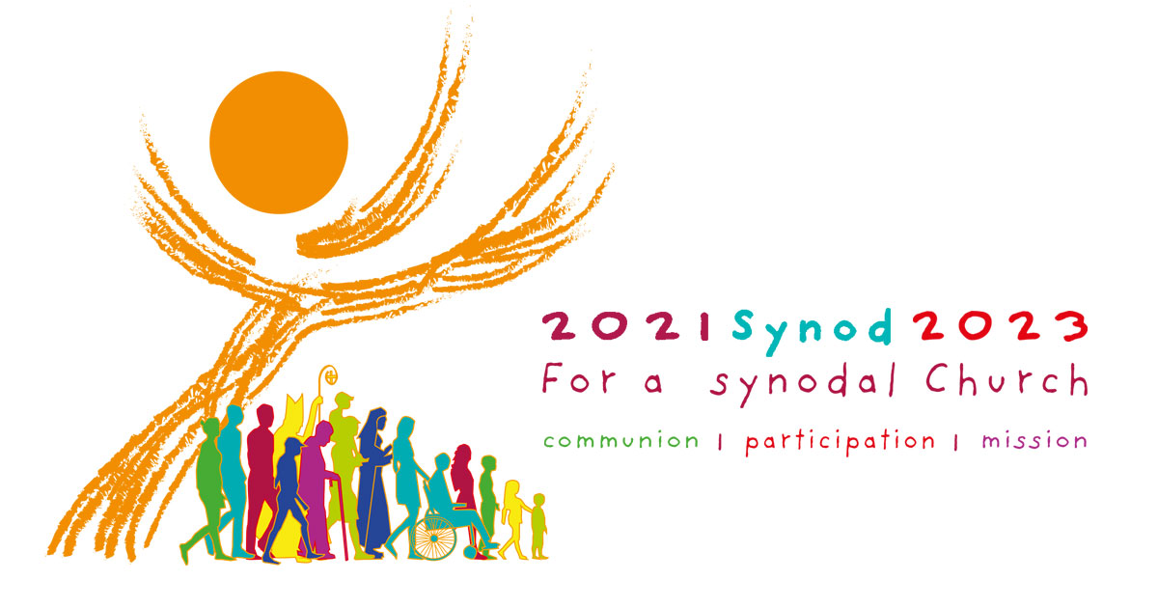

The Synod logo symbolism

- A large majestic tree full of wisdom and light, reaches for the sky – a sign of hope.
- It carries the Eucharist which shines like the sun.
- The horizontal branches opened like hands or wings suggest the presence of the Holy Spirit to guide us.
- Sheltering under the tree are the people of God – not static but on the move journeying together. The 15 silhouettes represent the diversity of our Church from the very young to the elderly, from religious to laity, from able-bodied to those with disabilities.
We are all making our way together united in Christ, the Way, the Truth and the Life.

