Parish of St Columba and St Theresa, Chester
Synod 2021-2023 - Reflecting on “Journeying Together”
Pope Francis has invited us all to ‘journey together’:
- to pray and reflect and to be inspired to dream about the Church we are called to be in this millennium.
- to imagine a different future for the Church in keeping with the Mission she has received
- to listen to the Holy Spirit
“The Church, the People of God, is a communion when all her members journey together and take an active part in her evangelizing mission”.
These are the three inter-related themes of the Synod.
Communion
Through our Baptism each of us is in Communion with Christ and through him the Father and the Holy Spirit. We are thereby all in communion - united with – each other.

Reflecting on what our experiences are:
- Pope Francis writes that ‘no human being is unworthy in the eyes of God’. Does what the Church does, what we as individuals do, live up to that statement?
- To whom does the Church need to listen?
- How are the laity, especially young people and women, listened to?
- How do prayer and liturgical celebrations inspire and direct our ‘journeying together’?
- A main objective of the Synod is to ‘regenerate relationships among members of the Christian communities and believers of other religions’. How could we do that?

Participation
We are all called to serve one another through the gifts we have received from the Holy Spirit. All are able to serve and be served.

Reflecting on how we have lived these experiences:
- Are your gifts known about and used in our church in Chester?
- Could they be better used in the service of the Church – the People of God – not just in Chester but in the wider world?
- How could this be done?
- What space is there in the Church for the voice of minorities, those excluded from church or wider society? Should we? How can we?
- Could we identify prejudices and stereotypes that hinder our listening?

Mission
The Church exists to share the Gospel with the world and witness to the love of God. All are worthy of and can offer witness.

Reflecting on where we feel that the Holy Spirit is leading the Church:
- We are invited to ‘imagine a different future for the Church’. What could /should be different in the church in future?
- What can we do to bring that about?
- Can you think of any groups of people who may feel excluded from the Church?
- What could the Church do to welcome those people?
- What experiences of dialogue and shared mission do we have with other Christian denominations, believers of other religions and non – believers?

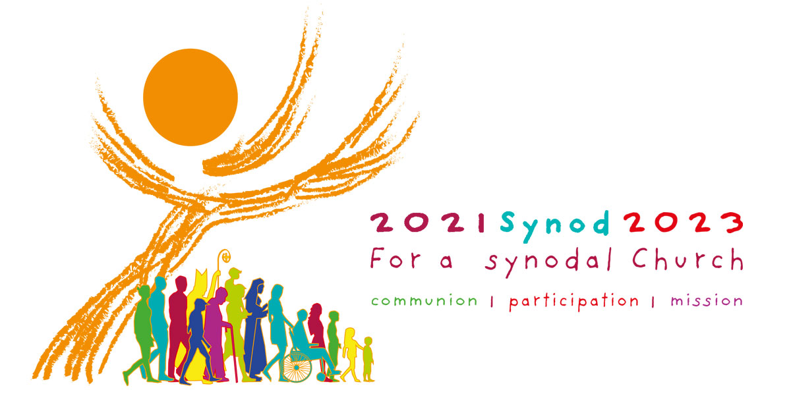
What are your thoughts and reflections? Please share them in the space below.

